Name: Gisella Adair
Assignment: Module 4 – MySQL Install

- Screenshot showing successfully connected to MySQL server
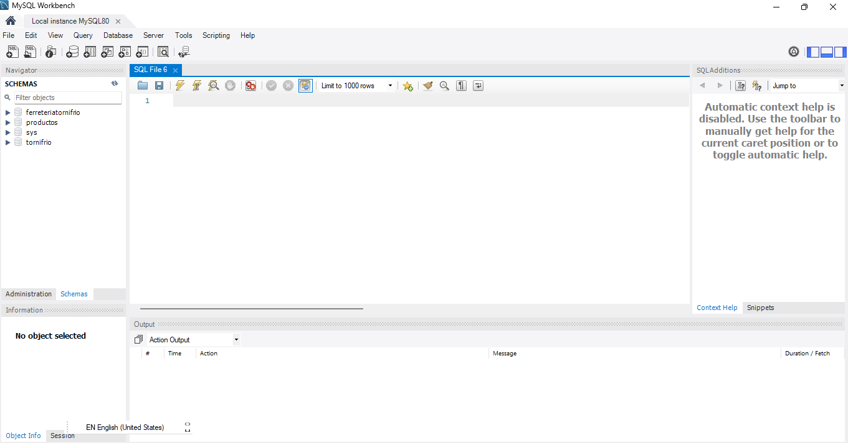
- Output grid including movies database
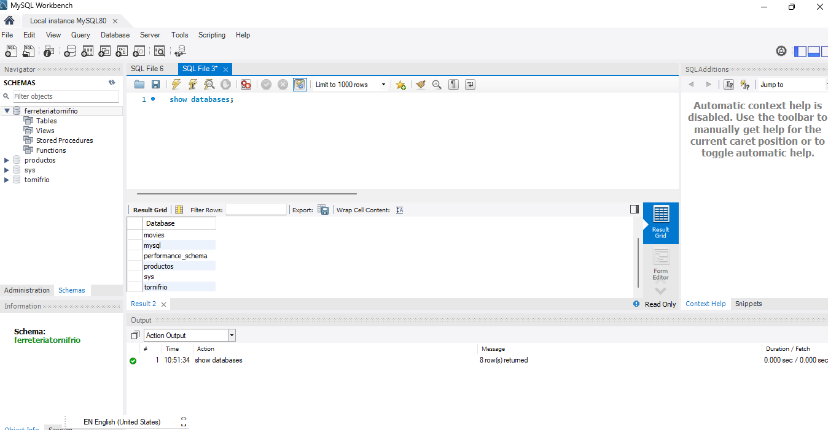

Optional: PyCharm Install + MySQL Link, VSCode + MySQL Link

